# TATA Internship :Empowering Business with Effective Insights

I Barkha Jha will be providing you my learning and the task performed for the completion of this Internship. This internship was available to me through Forage and 4 tasks was assigned to me for its completion those tasks Include:

Task 1: Framing the Business Scenario

Task2: Choosing the right Visuals

Task3: Creating Effective Visuals

Task4: Communicating Insights and Analysis

Task-1

To prepare for your meeting, you need to draft questions that you think will be important and relevant to the CEO and CMO.

This preparation will be your guide as you develop your presentation.Create a set of four questions that you anticipate each business leader will ask and want to know the answers to.

Make sure you differentiate your questions, as both the CEO and CMO view business decisions through different lenses

Task-2

Grammar of Graphics to understand the dimensions of visuals.

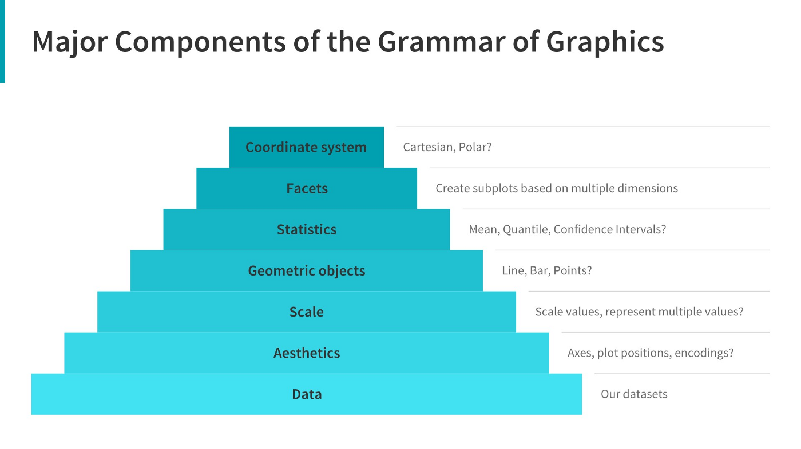

Task-3:

**Data cleanup**  
Before you can begin the analysis, make sure that the data is cleaned properly. You have noticed that the data contains some returns to the store which are provided in negative quantities and there are unit prices which were input in error. You will need to perform the following steps to clean this data.

Create each visual on a separate tab with the name of the tab displaying the question number. Once the visuals are created, save the files and upload them below.   
For Tableau users, you would need to upload in .twbx format whereas Power BI files need to be saved in .pbix format.

Task-4

First Visual

Regarding your first query, the CEO has asked for a revenue trend to determine whether retail sales are seasonal. According to the data, there are several months of the year that have significant development. According to the statistics, the first eight months of sales from January to August were very stable, with an average of $685K (Six hundred eighty-five thousand US dollars) in revenue per month. The increase in revenue begins in September, when it grows by 40% over the previous month. This pattern persisted up until November, when it rose to 1.5 million US dollars, the largest amount of the whole year. Unfortunately, since the data for December is insufficient, no inferences can be made from it. This research demonstrates how seasonality—which generally happens in the last four months of the year—affects retail store sales.

Second Visual

The top 10 countries with the most potential for growth are represented in the second graph. Since the UK already has a large demand and I understand you are more interested in nations where demand may be boosted, the UK is not included in these statistics. According to the data, sales of units and income are quite high in nations like the Netherlands, Ireland, Germany, and France. To guarantee that steps are taken to further seize these markets, I would propose concentrating on these nations.

Third Visual

The top 10 consumers who have made the most purchases from the business have been the subject of the third study. According to the statistics, there are not many differences between the top 10 consumer purchases. The fact that the highest revenue-producing consumer only spent 17% more than the second highest demonstrates that the company does not rely solely on a small number of consumers to generate income. This demonstrates that consumers' ability to negotiate is limited and that the state of business is positive.

Final Map Visual

The map chart concludes by comparing the places that have produced the greatest revenue to those that have not. Apart from the UK, it is clear that nations like the Netherlands, Ireland, Germany, France, and Australia generate large profits, and the company should invest more in these nations to boost product demand. The map also reveals that the majority of sales occur only in the European zone, with only a small number in the American region. Along with Russia, there is no market for the items in Africa or Asia. Sales revenues and profitability might increase with the implementation of a fresh strategy focused on these areas.